**Lab – 28**

**Student Name: Navneet P**

**Student ID: AF0411619**

***Topic: Scipy Introduction***

**What is Scipy?**

It is built on top of NumPy, another popular Python library for numerical computing, and provides additional functionality for various scientific and engineering tasks. Scipy is widely used in fields such as mathematics, physics, engineering, biology, and data science. Installation using **pip install scipy**.

**SciPy vs NumPy**

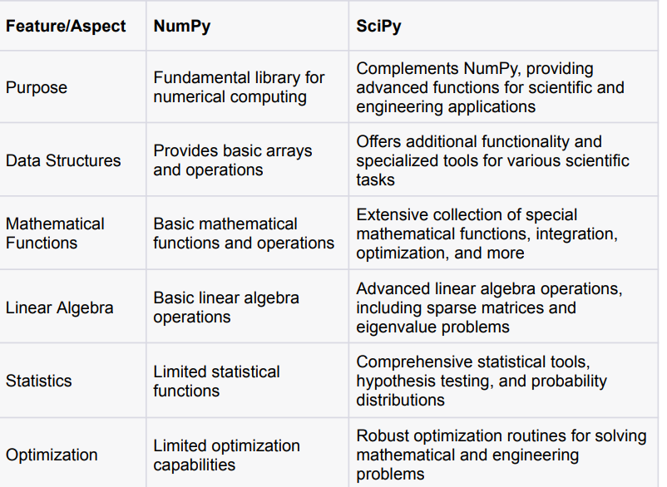

Question 1: Extract data from the given url and do the task mentioned below [Link](https://raw.githubusercontent.com/AnudipAE/DANLC/master/radius_data.csv) *Add a calculated area of circle column.*

Solution:

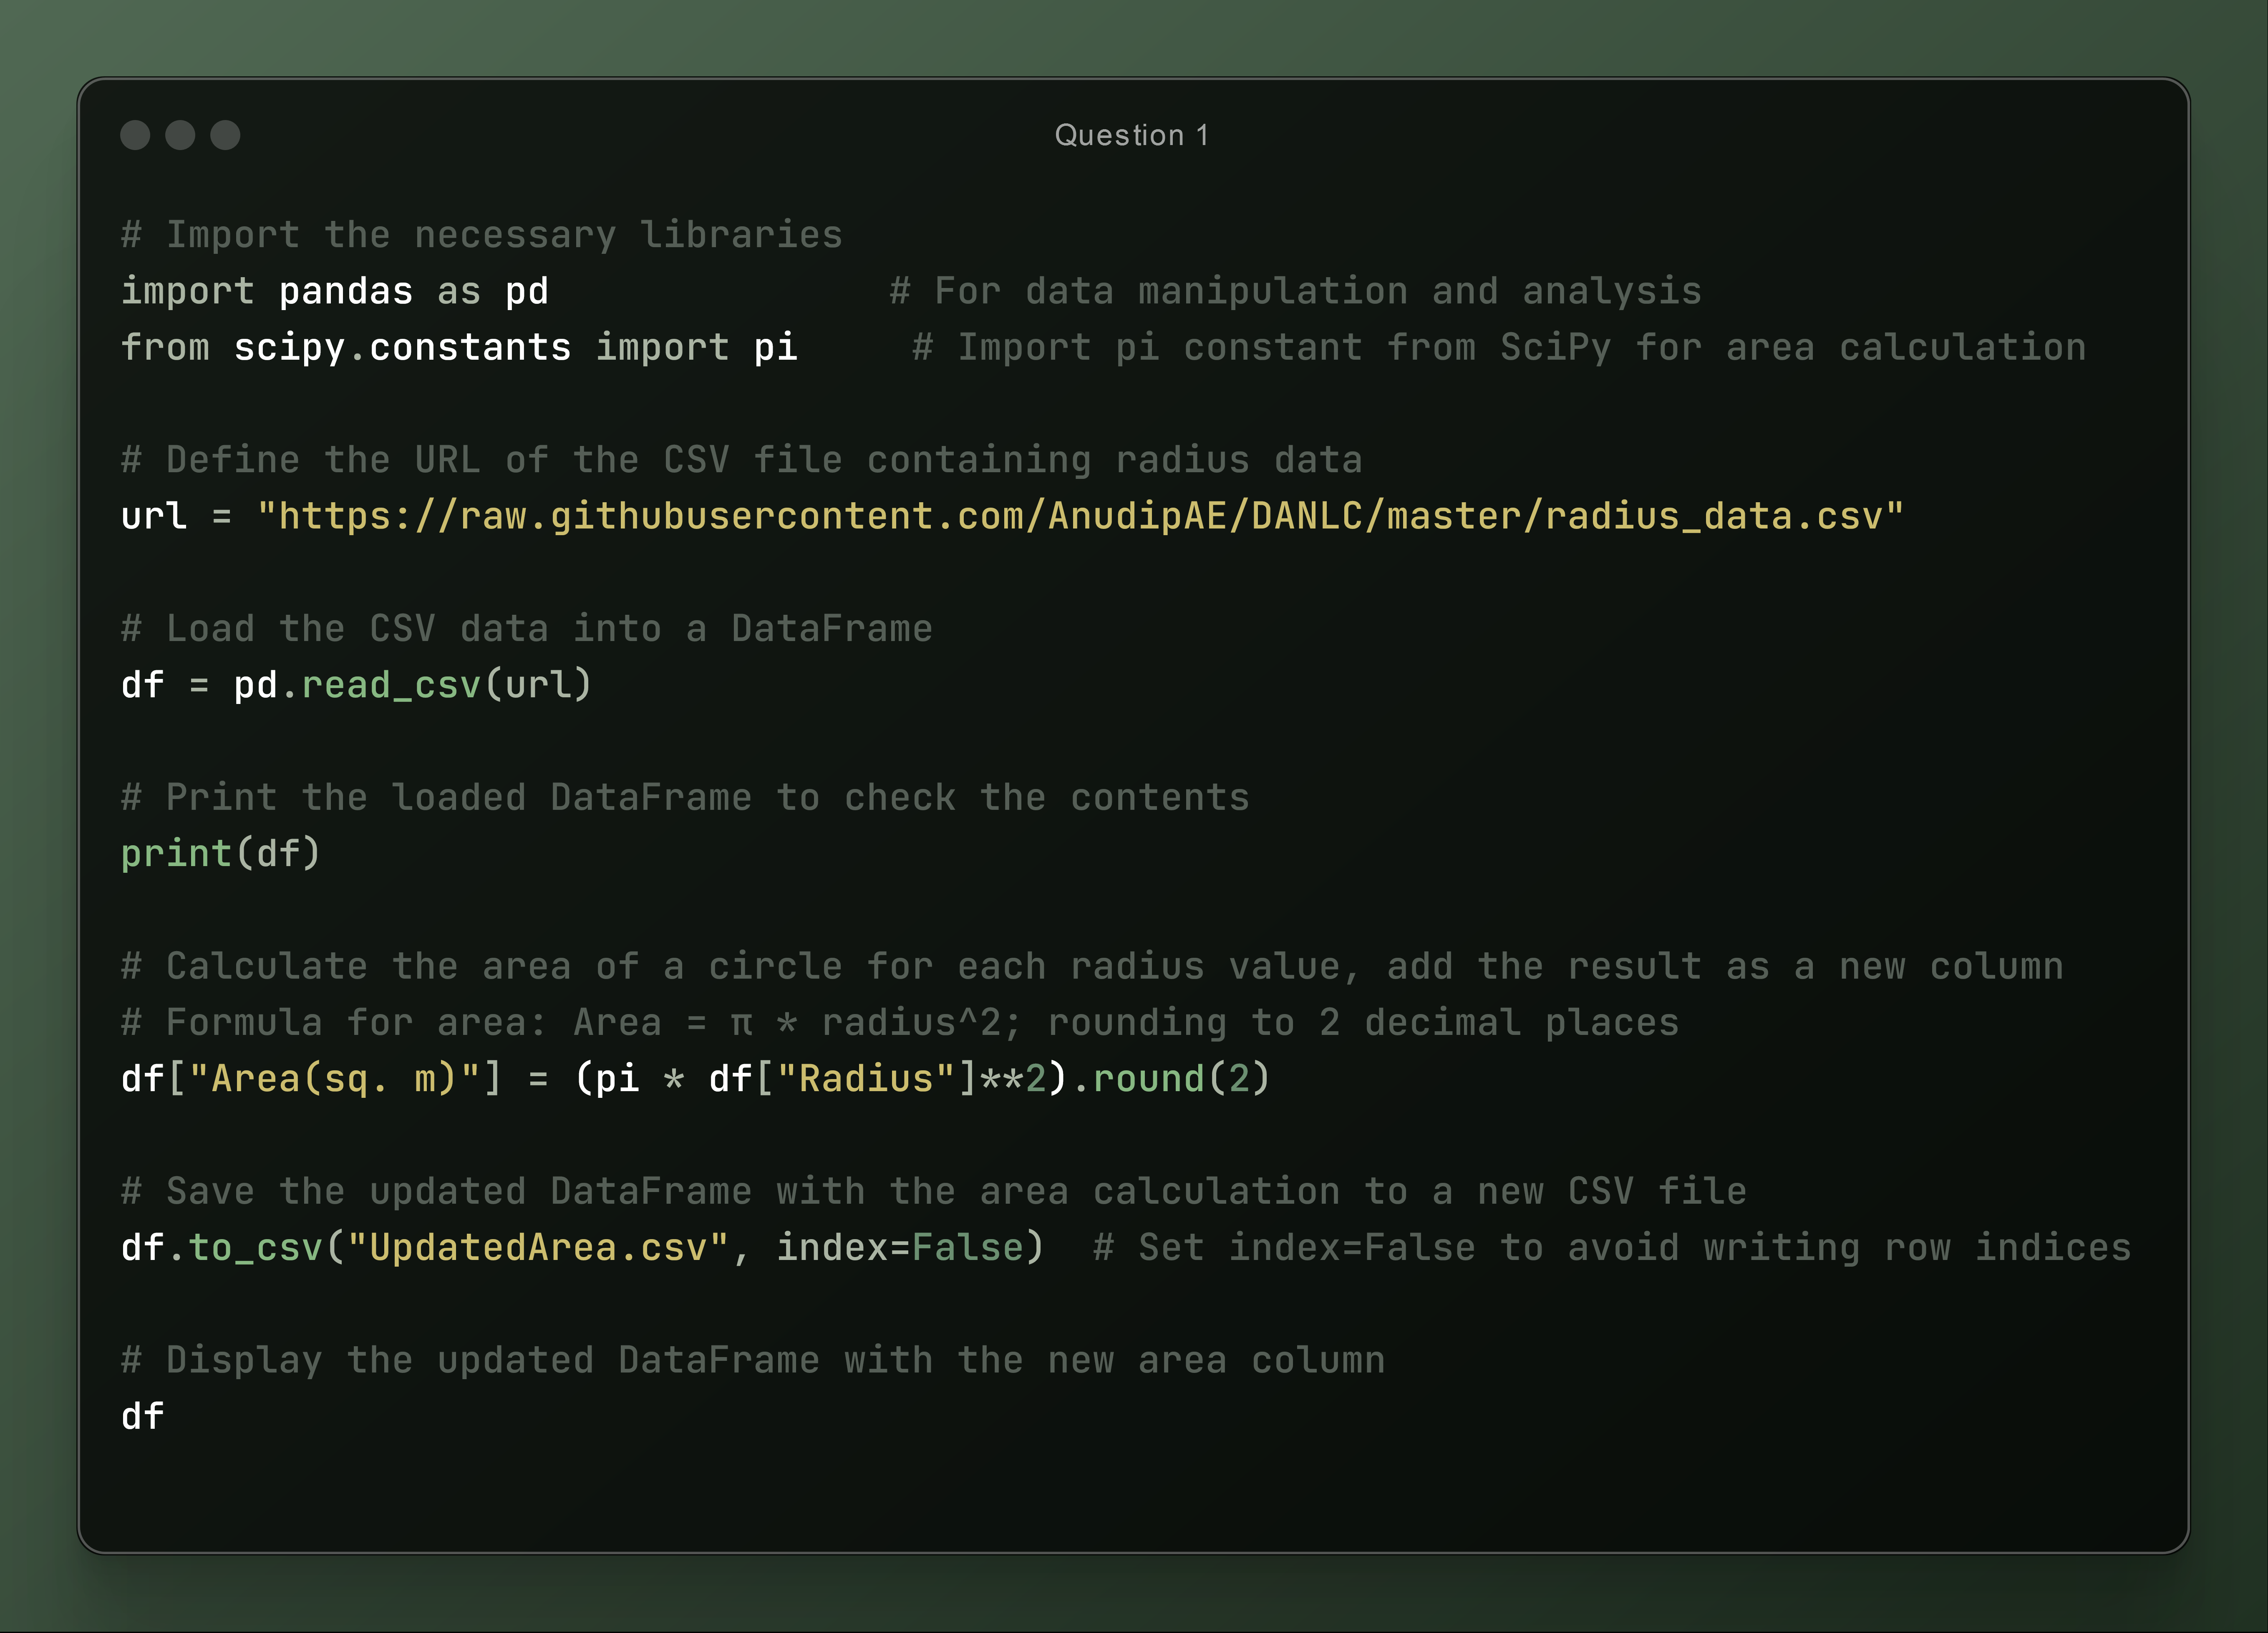

Output:

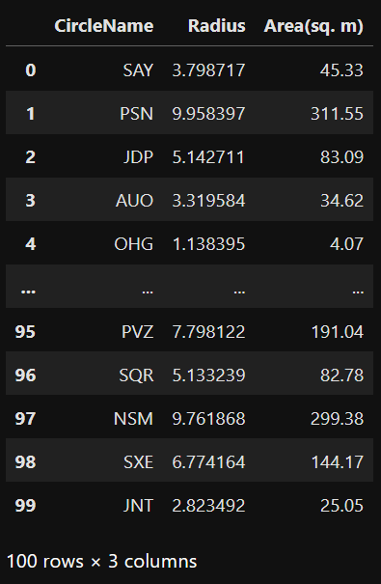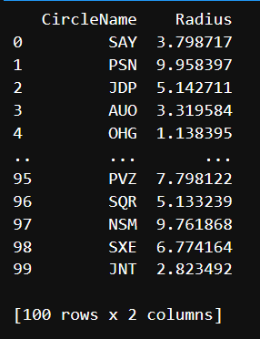

Question 2: Extract data from the given url and do the task mentioned below [Link](https://raw.githubusercontent.com/d4dipdas/DANLC/main/city_temperatures.csv) *Add a column with temperatures converted to Fahrenheit*

Solution:

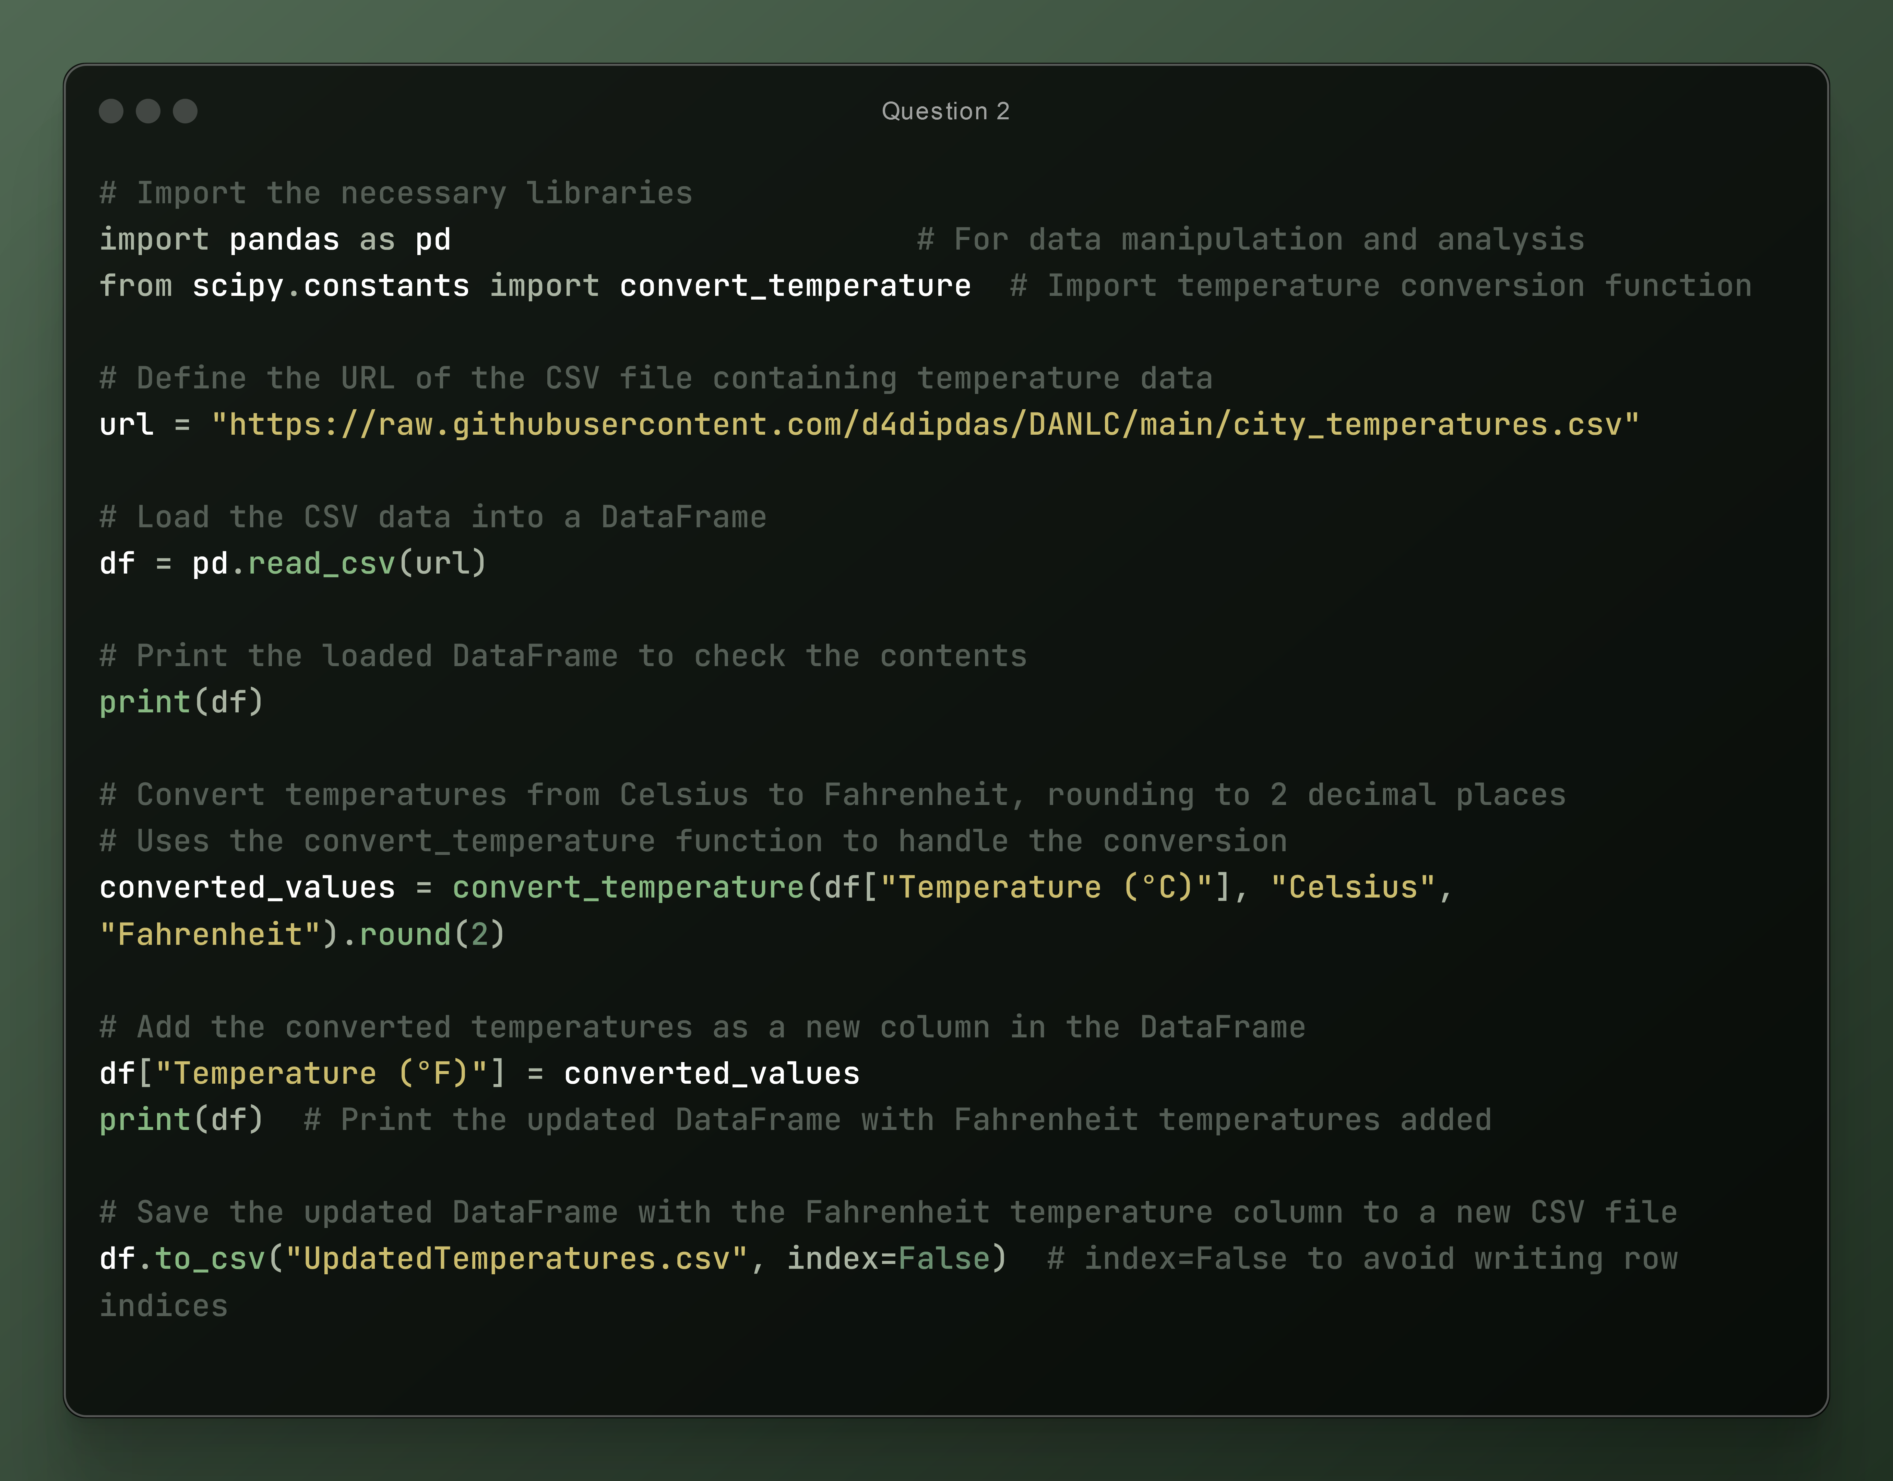

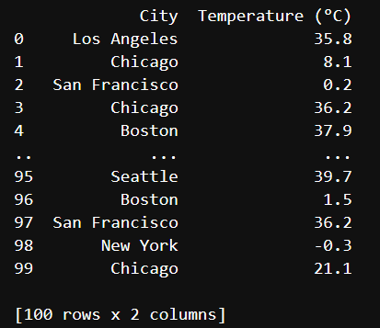Output:

